Peer Mediation
Training Manual

Section 1

Defining Conflict

What is Conflict?

Fill in the empty boxes with what your definition(s) of the word conflict.

Clash

Conflict

What’s the Problem?

Think about a conflict you’ve seen or experienced.

Check off the things to come to mind when you think of this conflict. Add to the list if you have more ideas.

Someone didn’t hear the whole story

Someone had the wrong information

Someone was confused or stressed

People saw things differently

Someone felt that something unfair happened

___________________________________________

___________________________________________

___________________________________________

Conflict Scenarios

Read the following scenarios and identify what the people in the scenarios might think problem is.

Best Friends Forever??
Brandy is so mad at her best friend Keisha. Well, at least they used to be best friends. See, she heard from some other people that Keisha’s been spreading rumors about her throughout the school. At lunch, Brandy decides to confront Keisha about the things she’s heard.

Brandy: I heard all the stuff you’ve been saying about me.
Keisha: What stuff? You know I wouldn’t talk about you like that.
Brandy: Stop lying! From now on don’t talk to me, don’t even look at me.
Keisha: Girl, I know you aren’t yelling at me. You’d better get out of my face before I have to hurt you.

Brandy ________________________________________________________

Keisha ________________________________________________________

Basketball Superstar
John is the best basketball player in his school. He knows he’s got serious game and welcomes the chance to show off his skills. One day he gets challenged to play one on one with Quentin. Now, Quentin’s a pretty good player, but not as good as John. The game starts off the way John is used to it going- he’s up 15 points in no time. Then all of a sudden Quentin starts taking shots and sinking baskets left and right. John figures he can still beat though him- after all, he is a star. But things never turn around. Quentin wins the game and John is not happy about it all. As Quentin turns around to celebrate with his friends, John rushes behind him and pushes him to the ground.

John ________________________________________________________

Quentin _______________________________________________________

Five Conflict Management Styles
Competition
- Forceful
- Low cooperation
- Relationships are low priority
- Used when quick action needs to be taken

Avoidance
- Withdrawing
- Low cooperation
- Tries to maintain relationships that conflict could hurt
- Used in issues of low importance, to reduce tension and to buy time

Accommodation
- Smoothing- puts others first
- High Cooperation
- Maintains relationships
- Used when the issue or outcome is not important to them

Compromise
- Giving up more than you want
- Medium Cooperation
- Maintains relationships
- Used when there is limited time and when a clear solution is possible

Collaboration
- A win-win long-term resolution
- High cooperation
- Maintains relationships
- Used when maintaining relationships is important, time is not an issue, the conflict is between peers and everyone shares their ideas to come to a resolution.

Back to the Middle

Think about a conflict you’ve seen and draw a picture of it in the first empty box. Draw a picture of the resolution you would like to see happen in the box.

Now fill in the box in the middle. What needs to happen between the first and last boxes?

What conflict management style did you use to resolve this conflict and why?

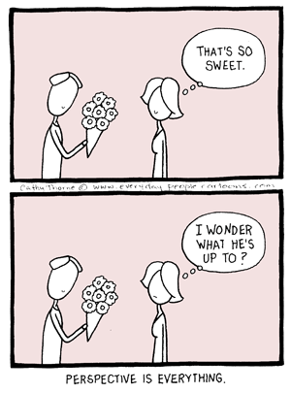

Section 2

PERSPECTIVE
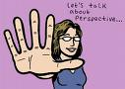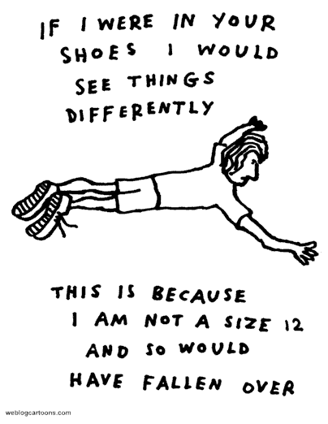

Scenario: The Family

During homeroom 2 students begin to argue over a seat. One of the students, Danny, says “fine, take the seat, at least my mom raised me right”.

The other student, whose mother had passed away recently, became very angry. “Don’t talk about my mother, you don’t know my family”!

Danny responded “I don’t want to know your stupid family, and I don’t want to know you, either!

His classmate responded “That’s fine by me, my cousins can take care of you after school!”
--------------------------------------------------------------------------------------------

When this happens, how do people respond? _______________

What is the best possible outcome?______________________________

What do people in this room believe should be the response? ____________________________________________

How did this influence my thinking?_______________________________
__________________________________________________________________________________________________________________________

Was this a ‘hot button’ topic for me? _______________________________

Name at least 3 other ‘hot button’ topics.

__________________________________________
__________________________________________
__________________________________________
__________________________________________

Perspective: a way of looking at something, point of view.

Think about a few events that shaped your life – draw pictures in each of the lenses to represent two events that influenced you.



How does this impact how you view the scenario we just completed?

_________________________________________________________________________________________________________________________________________________________________________________________________________________________________________________________________________________________________________________
The Bottom Line

Are you being:

Kind.
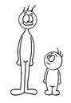
Considerate.
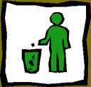

Truthful. 

Every time we speak, we create a path.


Scenario: Hygiene
While walking to the classroom, Tasha asks her friend, Toya, if she can borrow her comb. As Toya reaches for her purse, Toya’s friend, Terry, overhears the request.

Terry: “Toya, don’t give her your comb, that’s nasty”.

Tasha: “Terry, no one was talking to you. Mind your business”.

Terry: “Watch your mouth, I wasn’t talking to you, I was telling Toya not to give her comb to you because there is no telling when the last time was you washed your hair”

Toya: “Here Tasha, you can borrow it – but will you rinse it out when you are done?”

Tasha: “What are you trying to say? That is unnecessary. Keep your stupid comb!”
--------------------------------------------------------------------------------------------



What were the different viewpoints?________________________________
__________________________________________________________________________________________________________________________

Was Toya impacted by her peer’s? How? ___________________________
_____________________________________________________________

What would you have done if you were in Toya’s position? ____________
__________________________________________________________________________________________________________________________
Scenario: It all started when…

You are walking towards the cafeteria when you see the following scene:

Two girls are nose to nose inside the cafeteria. Classmates are gathered around chanting “fight, fight” and encouraging each of the girls to throw the first punch. One of the girls is a friend of yours. The other girl is new to the school. You step closer to see what is happening and you hear……



What can I do?

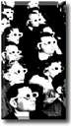

“FIGHT, FIGHT”!

--------------------------------------------------------------------------------------------

Be prepared to get involved in this scenario and respond with your thoughts and insights!

Section 3

Communication

Communication is the key to managing conflicts. Below is some information which may help you improve your communication skills.

Open-Ended Questions
Asking open-ended question is a good way to encourage people to talk and to practice being a good listener. It shows the person you are talking to that you are interested in what they have to say. Sometimes open-ended question aren’t even question, but statements which require an answer. The opposite of an open-ended question is a closed question. A closed question can be answered in one or two words and doesn’t give much information about the person who is being asked the question. Coming up with open-ended questions can be hard sometimes, but be creative and it’s bound to make you a better communicator.

In the table below are some closed questions. Can you think of a way to ask the question again in an open way?

Closed | Open-Ended
How are you?

What color shirt are you going to wear?

What’s you favorite subject

I Statements
Conflicts often get even more out of control when the parties involved feel like they are being accused of doing or something. They become defensive and focus on protecting themselves rather than listening to each other. In comes the “I statement”. An I statement is used to effectively get your voice heard, especially when you’re angry, without putting the blame on someone else.

An I statement has four parts:

- “I” : put the focus on yourself

- Feel : state what you feel (refer to the Feeling Words worksheet)

- When : state the event that is making you feel that way

- Because : state why you feel this way and the effect the event has had on you

Put in all together and you get:

I (#1) feel #2 , when #3 , because

#4 .

Here are some things to keep in mind when making I statements:

- Try not to add the words “like” or “that”. Saying “I feel that…” or “I like that…” is expressing a thought or opinion, not a feeling.
- Don’t turn it into a “you” statement. Saying things like “I feel that you …” puts the focus back in the other person
- Try to express positive feelings and not just negative ones.
- Match the level of feeling with the word’s you use. For example, if you are really, really happy, thrilled might be a better word to match the level of your feeling
Active Listening

Mediators should use a technique known as active listening. This is different from ordinary listening because it involves listening to gain a better understanding.
Instead of half listening, half thinking about something else and thinking up a response that will get your point across, try to listen attentively. Most people can remember at least one time when they felt like nobody was really listening to what they were saying. It was probably a very frustrating experience for you. During a mediation, it is only fair to give the people involved the attention they deserve.

Below are some tips that can help you become a good active listener.

- Focus on the person communicating. Give them your undivided attention.
- Be aware of the things you are doing non-verbally (non-verbal communication will be discussed in detail later).
- Give the person communicating a chance to rest after talking. Sometimes, we miss out on some important thoughts by jumping right in after a person stops talking.
- Make sure you really understand what the person said. In some cases, it is helpful to repeat what you think the person said. Also, asking questions can be useful in clarifying information. This is a great opportunity to practice using open-ended questions.

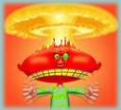

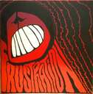

Section 4

Emotions
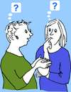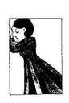
What It Means to Mediate



Being a mediator is a challenge. You are here to support your school community in diffusing conflict. It is important to respect self-expression and remember they came to work with us and find their solution.

What are some peaceful items in your toolbox now?

______________________________________________________________________________________

______________________________________________________________________________________

______________________________________________________________________________________

______________________________________________________________________________________

______________________________________________________________________________________

______________________________________________________________________________________

______________________________________________________________________________________

______________________________________________________________________________________

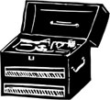

Pick 3 items from your toolbox that you can share with group.
Here are some additional items for your toolbox:
notice where you feel tense 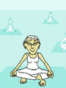

what is your body language saying about you right now? 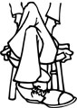

Are you sitting back in the chair? If not, why not?

Count to ten

Take a deep breath 

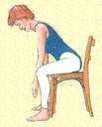Shift yourself in your seat

Picture a beautiful scene 
Remind yourself:

Don’t take it personally 

 Everyone is entitled to their own opinion

Let it go 


There are solutions

This is not my problem

While listening to the scenario, fill in the chart and determine what is are the facts and what are the feelings.

Fact Feeling

If Joanne told you her perspective, what would you say?________________
__________________________________________________________________________________________________________________________

If David told you his perspective, what would you say?_________________
__________________________________________________________________________________________________________________________

How can this problem be resolved? ________________________________
__________________________________________________________________________________________________________________________

Scenario - ZZZZZzzzz

For English class you have to practice public speaking. You are very nervous and tried to pick a topic that felt comfortable – fashion. You feel that your fashion sense is strong and have gotten a lot of compliments for how you ‘dress up’ the school uniform. On the day you present, you accessorize with jewelry and fashionable socks and shoes. When you approach the front of the room, your classmates are giggling and pointing at your feet. You look down and realize, horrified, that your socks don’t match your shoes. During your presentation, one of your classmates is sleeping – snoring, in fact. The teacher doesn’t seem to notice, or care, and has made it clear that the speaker is responsible for completing the entire assignment without interruption. It is hard to concentrate and now you realize that a different classmate has started mocking the snoring. To make matters worse, Jim is tapping his pencil on his desk and Dana keeps tossing paper balls at the back of Jim’s head. The teacher wakes up your classmate and tells Jim to stop tapping his pencil. “Why”, Jim asks. “I am still listening!” Several classmates sigh loudly and slouch in their seats as your teacher begins to lecture them about respectful listening.

What are some nonverbal cues that students shared during this scenario?

______________ _________________ ______________

______________ _________________ ______________

Share examples of insincere communication or mixed messages you have received.

Review the following statements. What would your body language be if you REALLY meant the following statements?

No, I am not mad anymore._______________________________________

_____________________________________________________________

My bad.______________________________________________________

Oops, I forgot._________________________________________________

What would your body language be if you really DIDN’T mean what you were saying?

That’s the truth, I swear!_________________________________________

_____________________________________________________________

That’s exciting, I am really happy for you.___________________________

_____________________________________________________________

I feel great. Just great.___________________________________________

_____________________________________________________________

It’s so good to see you.___________________________________________

_____________________________________________________________

What are some things that you noticed in this exercise? Give an example from your own experience.

Anger Log

- Write about a recent situation in which you were really angry.
_________________________________________________________________________________________________________________________________________________________________________________

How did you deal with it?
_________________________________________________________________________________________________________________________________________________________________________________

- Write about a recent situation in which you were EXTREMELY angry.
_________________________________________________________________________________________________________________________________________________________________________________

How did you deal with it?
_________________________________________________________________________________________________________________________________________________________________________________

Things that make me angry include:
_________________________________________________________________________________________________________________________________________________________________________________

I usually react by:
_________________________________________________________________________________________________________________________________________________________________________________

I would be willing to try to:
_________________________________________________________________________________________________________________________________________________________________________________

What else can you add to your toolbox?

Diffusing Anger



Revisit your toolbox – what can you do to diffuse the problem?

Avoid the Defensive Trap



Listen for the feelings. Consider perspective.


Imagine walking in their shoes…

1. When someone is really angry, there are a number of things you can do. You can …

a. Listen
b.
c.
d.

2. Name the feeling “that really pissed you off, didn’t it?”

a.
b.
c.

3. Begin a statement: “so you felt…..”

a.
b.
c.

4. Empathize – “was that hard?”

a.
b.
c.

5. Consider an alternative ending: what were some other options?

6.

7.

8.

9.

10.

11. Suggest a break (save face)

Section 5

Mediation Steps

Mediation Steps

Step 1: Introduction

This is the time to introduce yourself and make sure the people involved understand what you will be doing during the mediation.

We are your mediators ___________ and ___________, and we are here to help you resolve your conflict. We cannot make you do anything, but we will help you decided for yourselves how to resolve your conflict. We will not take sides and everything you say here is confidential – that means what we say must say in this room. Before we begin, we have requests posted on the wall that we ask you that you agree to (Go through list). Is there anything else you would like to add?

Step 2: Listening

The mediator’s role during this step is to give everyone a chance to tell what happened. If the people involved seem to be getting out of control, try referring them back to the requests they agreed on. If you feel you cannot handle something at any point let the adult in the room take over. Make sure to give each side an equal amount of time and attention to share their story. And remember, mediators should practice active listening (see Section 3 for a review).

You can say things like:
Please tell us what happened.
How do you feel about what happened?

Step 3: Problem Solving

During this step, the mediator helps the people involved in the conflict to identify what the problem really is and start thinking of solutions.

Problem solving involves the following steps:

- Identify and name the problem. Remember, the problem might not be what you think it is. It is up to the people involved in the conflict to figure this out.
- Understand the problem. Gather more information if you need to. People involved in the conflict should consider how the problem affects themselves as well as others. Seeing the problem in different ways helps in finding an effective solution.
- Brainstorm solutions. The people involved in the conflict should list possible ways to resolve it. Chances are some solutions they come up with won’t be realistic, but thinking about the many options will help them find the solution that will work for them.
- Try out a solution. The people involved in the conflict should consider how they think the many possibilities they thought of will work for them.
- Analyze how it worked out. Once the involved parties have imagined how the possible soluble would play out in the real world, they should discuss the features of the solution which were effective and which weren’t.

Here are some questions you can ask during this step:
What do you think the problem really is?
What are some possible solutions?
What are some ways you can both win in this situation?

Step 4: Choosing a Solution

After the problem solving, the people involved in the conflict must agree on one solution. By this point in the mediation, they should have figured out the best way for both sides to win.

During this step, ask questions like:
What are the pros and cons of the solutions you’ve given?
Which solution would you prefer?

Step 5: Conclusion
Once an agreement has been made, congratulate the participants on being able to work out their problems peacefully. Allow them to decide how they want to hold each other responsible for following through with the proposed solution.

Section 6



Being a Mediator
and a Student

Contract

I, _________________________ understand that I am commiting to the role

of Peer Mediator and agree that:

A Peer Mediator is:

Recommended by an adult in the school

Willing to co-facilitate sessions and mentor new trainers

A positive role model in the school community (90% attendance, passing all classes, etc.)

In attendance at peer mediator meetings and mediations as scheduled.

Willing to resolve personal or school related conflicts with the support of the peer mediation program.

